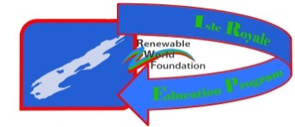
Renewable World Foundation
1001 Stephenson St.
Norway, MI 49870

Photo Release Form for Minors (if under 18)

Iron Mountain 8th grade Energy program

I hereby assign and grant to the Renewable World Foundation, as well as their authorized representatives, the right and permission to use and publish the photographs/film/videotapes/electronic representations and/or sound recordings made of me or my child at all RWF activities(IREP, E&M, Energy, Conservation, Day at the Dam, Canoeing,Solar) , and I hereby release RWF, the activity coordinators, and all employees, volunteers, related parties, or other organizations associated with the activity from any and all liability from such use and publication. I further authorize the reproduction, sale, copyright, exhibit, broadcast, electronic storage, and/or distribution of said photographs/film/videotapes/electronic representations and/or sound recordings without limitation at the discretion of RWF, and I specifically waive any right to any compensation I may have for any of the foregoing

Child’s Name (Print) | Parent’s Name (Print) | Parent’s Signature | Date

